Chapter 12, Solution 25.

Convert the delta-connected source to an equivalent wye-connected source and consider the single-phase equivalent.

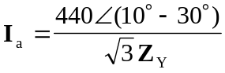
where

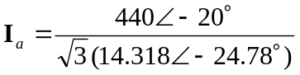\= 17.742∠4.78° amps.

I_{b} = I_{a}∠–120° = 17.742∠–115.22° amps.

I_{c} = I_{a}∠+120° = 17.742∠124.78° amps.

